|  |  |
| --- | --- |
| Gerb-BMSTU_01 | **Министерство науки и высшего образования Российской Федерации**  Калужский филиал  федерального государственного бюджетного  образовательного учреждения высшего образования  ***«Московский государственный технический университет имени Н.Э. Баумана (национальный исследовательский университет)»***  ***(КФ МГТУ им. Н.Э. Баумана)*** |

**ФАКУЛЬТЕТ** \_***ИУК «Информатика и управление»*\_\_**\_\_\_\_\_\_\_\_\_\_\_\_

**КАФЕДРА** \_\_***ИУК4 «Программное обеспечение ЭВМ и информационные технологии»***\_\_\_\_\_

**ДОМАШНЯЯ РАБОТА**

**ДИСЦИПЛИНА: «ПРОЕКТИРОВАНИЕ СИСТЕМ ХРАНЕНИЯ И ОБРАБОТКИ ДАННЫХ»**

|  |  |  |
| --- | --- | --- |
| Выполнил: студент гр. ИУК4-52Б | | \_\_\_\_\_\_\_\_\_\_\_\_\_\_\_\_\_ (\_\_\_\_\_Губин Е.В.\_\_\_\_\_)  (Подпись) (Ф.И.О.) |
| Проверил: | | \_\_\_\_\_\_\_\_\_\_\_\_\_\_\_\_\_ (\_\_\_\_Глебов С.А.\_\_\_\_\_)  (Подпись) (Ф.И.О.) |
| Дата сдачи (защиты):  Результаты сдачи (защиты): | | |
|  | - Балльная оценка:  - Оценка: | |

Калуга , 2024

**Цель:** Разработка  клиентского приложения (CRUD-операции с таблицами БД)

**Сервер**

**Роутер для постов:**

import { Router } from "express";

import postController from "../controllers/post-controller";

import authMiddleware from "../middlewares/auth-middleware";

import { param } from "express-validator";

const postRouter = Router();

postRouter.post("/", authMiddleware, postController.newPost);

postRouter.get("/all", authMiddleware, postController.getAllPosts)

postRouter.get(

"/repost/:childrenPostId",

param("childrenPostId").isNumeric(),

authMiddleware,

postController.getPostsByChildrenPostId

);

postRouter.get(

"/posts/:userId",

param("userId").isNumeric(),

authMiddleware,

postController.getPostsByUserId

);

postRouter.get(

"/:postId",

param("postId").isNumeric(),

authMiddleware,

postController.getPostBytId

);

postRouter.delete(

"/:postId",

param("postId").isNumeric(),

authMiddleware,

postController.deletePost

);

export default postRouter;

**Контроллер для постов:**

import { NextFunction, Request, Response } from "express";

import INewPost from "../interfaces/INewPost";

import postService from "../services/post-service";

import { validationResult } from "express-validator";

import ApiError from "../exceptions/ApiError";

class PostController {

async newPost(req: Request, res: Response, next: NextFunction) {

try {

const newPost: INewPost = req.body;

const authorId = Number(res.locals.userData.userId);

const newPostData = await postService.newPost(newPost, authorId);

res.json({ ...newPostData });

} catch (error) {

next(error);

}

}

async getPostsByUserId(req: Request, res: Response, next: NextFunction) {

try {

const errors = validationResult(req);

if (!errors.isEmpty()) {

throw ApiError.BadRequest("Incorrect userId", errors.array());

}

const userId = Number(req.params.userId);

const posts = await postService.getPostsByUserId(userId);

res.json({ posts });

} catch (error) {

next(error);

}

}

async getPostBytId(req: Request, res: Response, next: NextFunction) {

try {

const errors = validationResult(req);

if (!errors.isEmpty()) {

throw ApiError.BadRequest("Incorrect post id", errors.array());

}

const postId = Number(req.params.postId);

const postData = await postService.getPostById(postId);

res.json({ ...postData });

} catch (error) {

next(error);

}

}

async deletePost(req: Request, res: Response, next: NextFunction) {

try {

const errors = validationResult(req);

if (!errors.isEmpty()) {

throw ApiError.BadRequest("Incorrect postId", errors.array());

}

const postId = Number(req.params.postId);

const post = await postService.deletePostById(postId);

res.json({ ...post });

} catch (error) {

next(error);

}

}

async getPostsByChildrenPostId(

req: Request,

res: Response,

next: NextFunction

) {

try {

const errors = validationResult(req);

if (!errors.isEmpty()) {

throw ApiError.BadRequest(

"Incorrect children post id",

errors.array()

);

}

const childrenPostId = Number(req.params.childrenPostId);

const posts = await postService.getPostsByChildrenPostId(

childrenPostId

);

res.json({ posts });

} catch (error) {

next(error);

}

}

async getAllPosts(req: Request, res: Response, next: NextFunction) {

try {

const posts = await postService.getAllPosts();

res.json({ posts });

} catch (error) {

next(error);

}

}

}

export default new PostController();

**Сервис для постов:**

import INewPost from "../interfaces/INewPost";

import db from "../db";

import IPostFromDataBase from "../interfaces/IPostFromDataBase";

import PostDto from "../dtos/post-dto";

import userService from "./user-service";

import ApiError from "../exceptions/ApiError";

import dateTimeService from "./dateTime-service";

class PostService {

async newPost(newPost: INewPost, authorId: number) {

if (!(await userService.userIsExistsById(authorId))) {

throw ApiError.BadRequest("User with this id aren't exist");

}

if (

newPost.childrenPostId &&

!(await this.postIsExistsById(newPost.childrenPostId))

) {

throw ApiError.BadRequest("Children post isn't found");

}

const nowFormattedDateTime = dateTimeService.getNowDate();

const postFromDataBase: IPostFromDataBase = (

await db.query(

`INSERT INTO posts (content, publication\_date\_time, children\_post\_id, post\_author\_id) VALUES ($1, $2, $3, $4) RETURNING \*`,

[

newPost.content,

nowFormattedDateTime,

newPost.childrenPostId,

authorId,

]

)

).rows[0];

postFromDataBase.publication\_date\_time = dateTimeService.formatDateTime(

postFromDataBase.publication\_date\_time

);

return new PostDto(postFromDataBase);

}

async getPostsByUserId(userId: number) {

if (!(await userService.userIsExistsById(userId))) {

throw ApiError.BadRequest("User with this id aren't exist");

}

if (await userService.userIsExistsById(userId)) {

const posts: IPostFromDataBase[] = (

await db.query(

`SELECT \* FROM posts WHERE post\_author\_id = $1`,

[userId]

)

).rows;

return posts.map((post) => {

post.publication\_date\_time = dateTimeService.formatDateTime(

post.publication\_date\_time

);

return new PostDto(post);

});

}

throw ApiError.BadRequest("User with this id aren't exists");

}

async getPostById(postId: number) {

if (!(await this.postIsExistsById(postId))) {

throw ApiError.ResourseNotFound();

}

const postData: IPostFromDataBase = (

await db.query("SELECT \* FROM posts WHERE post\_id = $1", [postId])

).rows[0];

postData.publication\_date\_time = dateTimeService.formatDateTime(

postData.publication\_date\_time

);

return new PostDto(postData);

}

async deletePostById(postId: number) {

if (await this.postIsExistsById(postId)) {

const post: IPostFromDataBase = (

await db.query(

"DELETE FROM posts WHERE post\_id = $1 RETURNING \*",

[postId]

)

).rows[0];

post.publication\_date\_time = dateTimeService.formatDateTime(

post.publication\_date\_time

);

return new PostDto(post);

}

throw ApiError.BadRequest("Post with this id aren't found");

}

async postIsExistsById(postId: number) {

const postById: IPostFromDataBase[] = (

await db.query(`SELECT \* FROM posts WHERE post\_id = $1`, [postId])

).rows;

if (postById.length == 0) {

return false;

}

return true;

}

async getPostsByChildrenPostId(childrenPostId: number) {

if (!(await this.postIsExistsById(childrenPostId))) {

throw ApiError.BadRequest("Children post isn't found");

}

const posts: IPostFromDataBase[] = (

await db.query("SELECT \* FROM posts WHERE children\_post\_id = $1", [

childrenPostId,

])

).rows;

return posts.map((post) => {

post.publication\_date\_time = dateTimeService.formatDateTime(

post.publication\_date\_time

);

return new PostDto(post);

});

}

async getPostIdsByAuthorId(authorId: number) {

if (!(await userService.userIsExistsById(authorId))) {

throw ApiError.BadRequest("Author id isn't found");

}

const ids: number[] = (

await db.query(

"SELECT post\_id FROM posts WHERE post\_author\_id = $1",

[authorId]

)

).rows;

return ids;

}

async getAllPosts() {

const posts: IPostFromDataBase[] = (

await db.query("SELECT \* FROM posts", [])

).rows;

return posts.map((post) => {

post.publication\_date\_time = dateTimeService.formatDateTime(

post.publication\_date\_time

);

return new PostDto(post);

});

}

}

export default new PostService();

**Клиент**

**Axios для работы с сервером над постами:**

import $api from "../http";

import IGetPost from "../interfaces/IResponses/IGetPost";

export default class PostService {

static async getPostsByUserId(userId: number) {

return await $api.get<{ posts: IGetPost[] }>(`/post/posts/${userId}`);

}

static async getPostById(postId: number) {

return await $api.get<IGetPost>(`/post/${postId}`);

}

static async getPostsByChildrenPostId(childrenPostId: number) {

return await $api.get<{ posts: IGetPost[] }>(

`/post/repost/${childrenPostId}`

);

}

static async newPost(

content: string,

childrenPostId: number | null = null

) {

return await $api.post<IGetPost>("/post", { content, childrenPostId });

}

static async deletePost(postId: number) {

return await $api.delete<IGetPost>(`/post/${postId}`);

}

static async getALlPosts() {

return await $api.get<{ posts: IGetPost[] }>("/post/all");

}

}

**Пользовательский интерфейс**

**Компонент пост:**

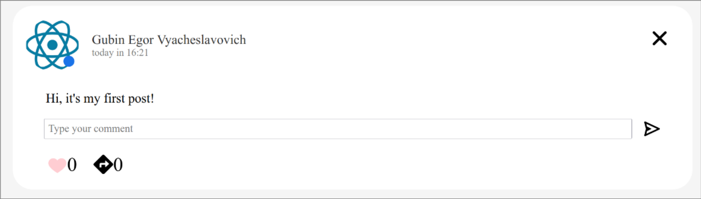Рис. 1: Пост

import React, { ChangeEvent, useContext, useEffect, useState } from "react";

import s from "./Post.module.css";

import IPost from "../../interfaces/IProps/IPost";

import DateTimeService from "../../services/dateTime-service";

import PostService from "../../services/post-service";

import IGetPost from "../../interfaces/IResponses/IGetPost";

import IUser from "../../interfaces/IResponses/IUser";

import UserService from "../../services/user-service";

import ProfileImageService from "../../services/profileImage-service";

import classNames from "classnames";

import IGetComment from "../../interfaces/IResponses/IGetComment";

import Comment from "../Comment/Comment";

import CommentService from "../../services/comment-service";

import { BiSend } from "react-icons/bi";

import { FcLikePlaceholder } from "react-icons/fc";

import { FcLike } from "react-icons/fc";

import ReactionService from "../../services/reaction-service";

import IGetReaction from "../../interfaces/IResponses/IGetReaction";

import { Context } from "../..";

import { FaDirections } from "react-icons/fa";

import { observer } from "mobx-react-lite";

import { IoClose } from "react-icons/io5";

import PostImageService from "../../services/postImage-service";

import ImageSlider from "../ImageSlider/ImageSlider";

import { useNavigate } from "react-router-dom";

import io from "socket.io-client";

import { globalSocket } from "../../globalSocket";

import { GrStatusGoodSmall } from "react-icons/gr";

const Post: React.FC<IPost> = ({

post,

isChild,

setCreatePostFormIsOpened,

setRepost,

setPosts,

}) => {

const { store } = useContext(Context);

const [postAvatarImage, setPostAvatarImage] = useState("");

const [author, setAuthor] = useState({} as IUser);

const [postImages, setPostImages] = useState<string[]>([]);

const [comments, setComments] = useState<IGetComment[]>([]);

const [childPost, setChildPost] = useState<JSX.Element | null>(null);

const [showAllComments, setShowAllComments] = useState<boolean>(false);

const [newComment, setNewComment] = useState("");

const [isReaction, setIsReaction] = useState(false);

const [reactionsAmount, setReactionsAmount] = useState(0);

const [repostsAmount, setRepostsAmount] = useState(0);

const [isOnline, setIsOnline] = useState(false)

const navigate = useNavigate();

const openPageByAvatar = () => {

if (store.user.userId !== post.postAuthorId) {

navigate(`/profile/${post.postAuthorId}`);

}

};

const loadPostAvatarImage = async () => {

setPostAvatarImage(

(await ProfileImageService.getProfileImage(post.postAuthorId)).data

.src

);

};

const loadAuthor = async () => {

setAuthor((await UserService.getUserById(post.postAuthorId)).data);

};

const loadPostImages = async () => {

setPostImages(

(await PostImageService.getPostImages(post.postId)).data.postImages

);

};

const loadComments = async () => {

setComments(

(

await CommentService.getCommentsByPostId(post.postId)

).data.comments.sort((first, second) => {

const dateFirst = new Date(first.commentDateTime);

const dateSecond = new Date(second.commentDateTime);

return dateSecond.getTime() - dateFirst.getTime();

})

);

};

const loadChildPost = async () => {

if (post.childrenPostId) {

const childPostData = (

await PostService.getPostById(post.childrenPostId)

).data;

setChildPost(<Post post={childPostData} isChild={true} />);

}

};

const laodReactions = async () => {

const reactionsData = (

await ReactionService.getReactionsByPostId(post.postId)

).data.reactions;

setReactionsAmount(reactionsData.length);

for (let i = 0; i < reactionsData.length; i++) {

if (reactionsData[i].reactionAuthorId === store.user.userId) {

setIsReaction(true);

return;

}

}

};

const loadReposts = async () => {

setRepostsAmount(

(await PostService.getPostsByChildrenPostId(post.postId)).data.posts

.length

);

};

const loadIsOnline = async () => {

setIsOnline((await UserService.getStatus(post.postAuthorId)).data.isOnline)

}

useEffect(() => {

loadAuthor();

loadPostImages();

loadChildPost();

loadPostAvatarImage();

laodReactions();

loadReposts();

loadIsOnline()

if (!isChild) {

loadComments();

}

const socket = io(globalSocket);

socket.emit("subscribe\_image", {

userId: post.postAuthorId,

});

socket.emit("subscribe\_like", {

postId: post.postId,

authorId: store.user.userId,

});

socket.emit("subscribe\_online", {userId: post.postAuthorId });

socket.on("set\_image", () => {

loadPostAvatarImage();

});

socket.on("set\_like", ({ operation }: { operation: number }) => {

console.log(operation)

setReactionsAmount((prev) => prev + operation);

});

socket.on("set\_status", ({ isOnline }: { isOnline: boolean }) => {

setIsOnline(isOnline);

});

return () => {

socket.off("set\_status");

socket.off("set\_like");

socket.off("set\_image");

socket.disconnect();

};

}, []);

return (

<div className={classNames(s.post, { [s.left\_border]: isChild })}>

<div className={s.post\_header}>

<div

className={s.profile\_post\_image}

onClick={openPageByAvatar}

style={{

backgroundImage: `url(${postAvatarImage})`,

}}

>

{isOnline && (

<GrStatusGoodSmall className={s.online} />

)}</div>

<div className={s.date\_time\_fio}>

<div className={s.post\_fio}>

{[

author.lastName,

author.firstName,

author.patronymic,

].join(" ")}

</div>

<div className={s.pub\_post\_date\_time}>

{DateTimeService.formDate(post.publicationDateTime)}

</div>

</div>

</div>

<div className={s.post\_content}>{post.content}</div>

<ImageSlider images={postImages} />

{childPost}

{comments.length !== 0 &&

comments.map((comment, index) => {

if (showAllComments || comments.length <= 2)

return (

<Comment

isMyPost={

store.user.userId === post.postAuthorId

}

comment={comment}

key={comment.commentId}

setComments={setComments}

/>

);

if (index <= 1)

return (

<Comment

isMyPost={

store.user.userId === post.postAuthorId

}

comment={comment}

key={comment.commentId}

setComments={setComments}

/>

);

return null;

})}

{comments.length > 2 ? (

showAllComments ? (

<span

className={s.manage\_comments}

onClick={() => setShowAllComments(false)}

>

Hide comments

</span>

) : (

<span

className={s.manage\_comments}

onClick={() => setShowAllComments(true)}

>

Show all commets...

</span>

)

) : null}

{!isChild ? (

<div className={s.new\_comment}>

<textarea

placeholder="Type your comment"

className={s.comment\_area}

rows={1}

value={newComment}

onChange={(event) => {

const textarea = event.target;

textarea.style.height = "auto";

textarea.style.height =

textarea.scrollHeight + "px";

setNewComment(event.target.value);

}}

></textarea>

<BiSend

onClick={() => {

CommentService.newComment(newComment, post.postId)

.then((response) => response.data)

.then((data) =>

setComments((prev) => [data, ...prev])

);

setNewComment("");

}}

className={s.send\_comment}

/>

</div>

) : null}

{isChild ? null : (

<div className={s.reaction\_repost}>

<div

className={s.reactions\_amount}

onClick={

isReaction

? () => {

ReactionService.deleteReaction(

post.postId

)

.then((response) => response.data)

.then((data) => {

setReactionsAmount(

(prev) => prev - 1

);

setIsReaction(false);

});

const socket = io(globalSocket);

socket.emit("change\_like", {

postId: post.postId,

operation: -1,

authorId: store.user.userId,

});

}

: () => {

ReactionService.newReaction(post.postId)

.then((response) => response.data)

.then((data) => {

setReactionsAmount(

(prev) => prev + 1

);

setIsReaction(true);

});

const socket = io(globalSocket);

socket.emit("change\_like", {

postId: post.postId,

operation: 1,

authorId: store.user.userId,

});

}

}

>

{isReaction ? (

<FcLike className={s.reaction\_button} />

) : (

<FcLikePlaceholder className={s.reaction\_button} />

)}{" "}

{reactionsAmount}{" "}

</div>

<div

className={classNames({

[s.reposts\_amount]:

post.postAuthorId !== store.user.userId,

[s.repost\_amount\_unself]:

post.postAuthorId === store.user.userId,

})}

onClick={

post.postAuthorId === store.user.userId

? () => {}

: () => {

if (

setCreatePostFormIsOpened &&

setRepost

) {

setCreatePostFormIsOpened(true);

setRepost(post);

}

}

}

>

<FaDirections className={s.repost\_button} />{" "}

{repostsAmount}

</div>

</div>

)}

{isChild || post.postAuthorId !== store.user.userId ? null : (

<IoClose

className={s.close}

onClick={() => {

PostService.deletePost(post.postId)

.then((response) => response.data)

.then((data) => {

if (setPosts)

setPosts((prev) =>

prev.filter(

(postData) =>

postData.postId !== post.postId

)

);

const socket = io(globalSocket);

socket.emit("delete\_post", {

postId: data.postId,

authorId: data.postAuthorId,

});

});

}}

/>

)}

</div>

);

};

export default observer(Post);

**Форма для создания поста:**

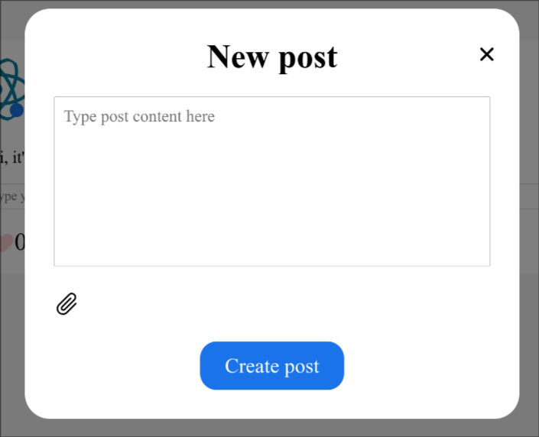Рис. 2: Форма для создания поста

import React, { ChangeEvent, useRef, useState } from "react";

import s from "./NewPostForm.module.css";

import { FormButton } from "../UI/FormButton/FormButton";

import { GoPaperclip } from "react-icons/go";

import PostService from "../../services/post-service";

import PostImageService from "../../services/postImage-service";

import INewPostForm from "../../interfaces/IProps/INewPostForm";

import io from "socket.io-client";

import { globalSocket } from "../../globalSocket";

export const NewPostForm: React.FC<INewPostForm> = ({

setPosts,

repost,

setRepost,

setCreatePostFormIsOpened,

isFromPostsPage,

}) => {

const [content, setContent] = useState("");

const fileInputRef = useRef<HTMLInputElement>(null);

const [files, setFiles] = useState<File[]>([]);

const [filesImages, setFilesImages] = useState<string[]>([]);

const setImages = (event: ChangeEvent<HTMLInputElement>) => {

const filesEvent = event.target.files;

if (!filesEvent || filesEvent.length === 0) {

return;

}

const permittedTypes = ["image/jpeg", "image/jpg", "image/png"];

for (let i = 0; i < filesEvent.length; i++) {

if (!permittedTypes.includes(filesEvent[i].type)) {

return;

}

}

const filesArray = Array.from(filesEvent);

setFiles(filesArray);

setFilesImages(

filesArray.map(

(fileData) => `url(${URL.createObjectURL(fileData)})`

)

);

};

return (

<div className={s.new\_post\_form}>

<div className={s.container}>

<textarea

rows={8}

placeholder="Type post content here"

className={s.content}

value={content}

onChange={(event) => setContent(event.target.value)}

></textarea>

<div className={s.selected\_images}>

<GoPaperclip

className={s.clip}

onClick={() => fileInputRef.current?.click()}

/>

{filesImages.map((file) => (

<div

className={s.image}

style={{

backgroundImage: file,

}}

></div>

))}

</div>

<input

ref={fileInputRef}

type="file"

multiple={true}

accept=".jpg, .jpeg, .png"

onChange={setImages}

className={s.file\_input}

/>

</div>

<FormButton

onClick={

repost

? async () => {

const post = (

await PostService.newPost(

content,

repost.postId

)

).data;

await PostImageService.newPostImages(

files,

post.postId

);

setRepost(null);

setContent("");

setFiles([]);

setFilesImages([]);

setCreatePostFormIsOpened(false);

if (isFromPostsPage)

setPosts((prev) => [post, ...prev]);

const socket = io(globalSocket);

socket.emit("new\_post", { post });

}

: async () => {

const post = (await PostService.newPost(content))

.data;

await PostImageService.newPostImages(

files,

post.postId

);

setContent("");

setFiles([]);

setFilesImages([]);

setCreatePostFormIsOpened(false);

setPosts((prev) => [post, ...prev]);

const socket = io(globalSocket);

socket.emit("new\_post", { post });

}

}

type="button"

>

Create post

</FormButton>

</div>

);

};

**Страница постов:**

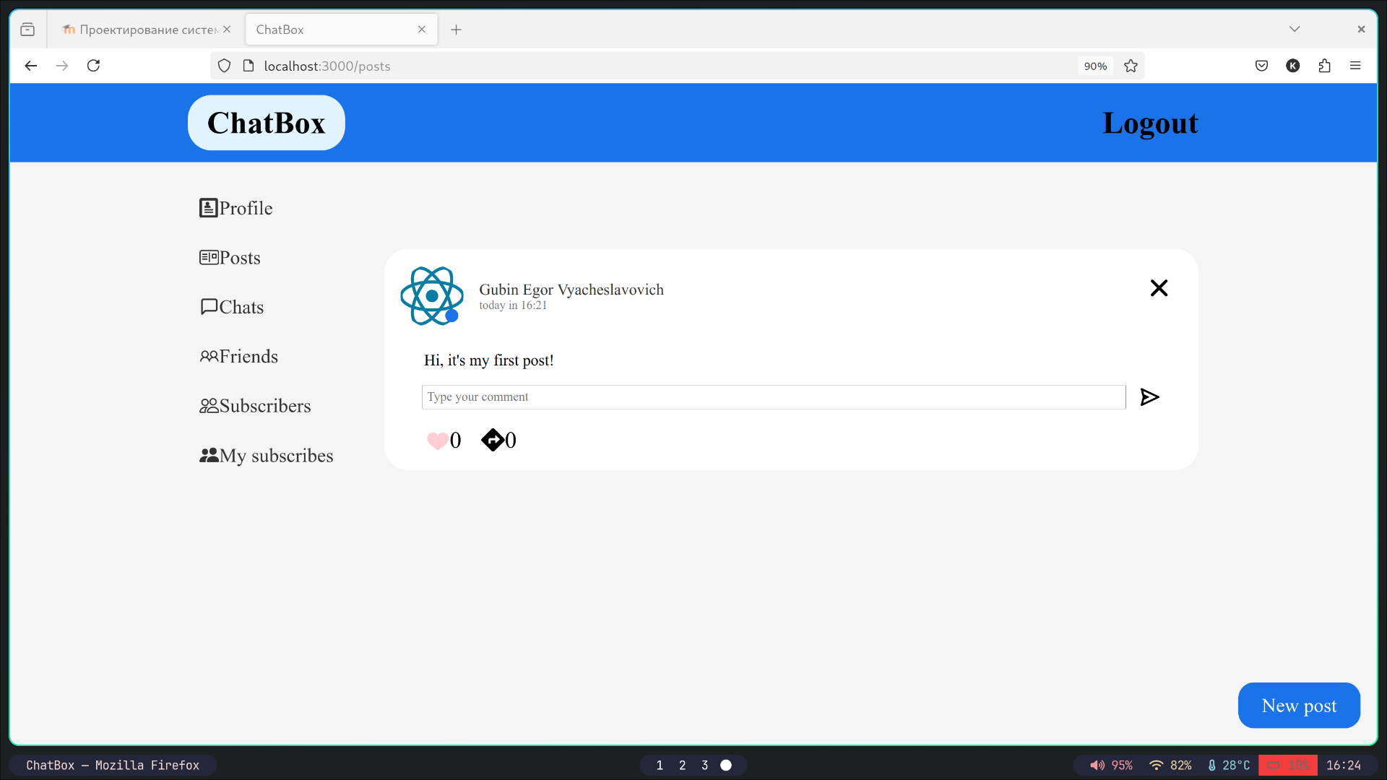Рис. 3: Страница постов

import React, { useEffect, useState } from "react";

import s from "./PostsPage.module.css";

import IGetPost from "../../interfaces/IResponses/IGetPost";

import PostService from "../../services/post-service";

import Post from "../Post/Post";

import { ModalWindow } from "../ModalWindow/ModalWindow";

import { NewPostForm } from "../NewPostForm/NewPostForm";

import { FormButton } from "../UI/FormButton/FormButton";

export const PostsPage: React.FC = () => {

const [posts, setPosts] = useState<IGetPost[]>([]);

const [createPostFormIsOpened, setCreatePostFormIsOpened] = useState(false);

const [repost, setRepost] = useState<IGetPost | null>(null);

const loadPosts = async () => {

const postsData = (await PostService.getALlPosts()).data.posts;

setPosts(

postsData.sort((first, second) => {

const dateFirst = new Date(first.publicationDateTime);

const dateSecond = new Date(second.publicationDateTime);

return dateSecond.getTime() - dateFirst.getTime();

})

);

};

useEffect(() => {

loadPosts();

}, []);

return (

<div>

{posts.map((post) => (

<Post

key={post.postId}

post={post}

isChild={false}

setRepost={setRepost}

setCreatePostFormIsOpened={setCreatePostFormIsOpened}

setPosts={setPosts}

/>

))}

<FormButton

className={s.new\_post}

type="button"

onClick={() => setCreatePostFormIsOpened(true)}

>

New post

</FormButton>

<ModalWindow

isOpened={createPostFormIsOpened}

setIsOpened={setCreatePostFormIsOpened}

header="New post"

>

<NewPostForm

setCreatePostFormIsOpened={setCreatePostFormIsOpened}

setPosts={setPosts}

repost={repost}

setRepost={setRepost}

isFromPostsPage={true}

/>

</ModalWindow>

</div>

);

};

**Вывод:** в ходе лабораторной работы были реализованы CRUD операции для работы с постами.